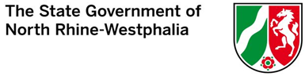
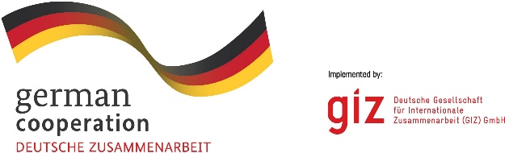

TRAINING FOR YOUNG PROFESSIONALS FROM MACEDONIA AND KOSOVO
3-6 MONTH INTERNSHIP IN GERMANY FROM April – June (September) 2024

Apply, when you can answer „Yes“ to these five questions:

- I am a citizen of North Macedonia or of Kosovo: YES NO

- I am between 18 and 28 years old: YES NO
- At least one of the following statements describes my educational background: YES NO
  - I am currently studying in a University / Academy and by the end of February 2024 I would have finished at least 5 semesters.
  - I have successfully finished my studies, however, would like to continue my education and will apply / have already applied for another degree programme.

  - I will have successfully finished my studies until February 01, 2024, and I have no or less than 1 year work experience.

  - I am a young professional with less than 1 year of work experience.
- My English and/or German skills are very good: YES NO
- I am interested in interning in Germany and have the relevant knowledge to do an internship in one of the following spheres: YES NO

- Circular economy and recycling, water and wastewater management, energy supply and renewable energies, architecture/urban planning and energy-efficient construction, digitization and IT, business administration, environmental management and green economy, mechanical engineering, transport and logistics, economics, sustainable tourism
If you answered “Yes” to these questions, then apply!
More information in the Programme Brochure

Contact: Dr. Berthold Volberg (GIZ):
E-Mail: berthold.volberg@giz.de
Oliver Nachevski (GIZ Office North Macedonia)
E-Mail: oliver.nachevski@giz.de

Deadline for applications: August 31, 2023

